**TASK-02**

**Retail store offers maximum amount of credit.**

**EXPLANATION:**

The program takes input from the user as THE MAXIMUM CREDIT offered by a retail store. Then asks him to enter his/her amount used. At last tells the user about his remaining amount, as output.

**INPUT:**

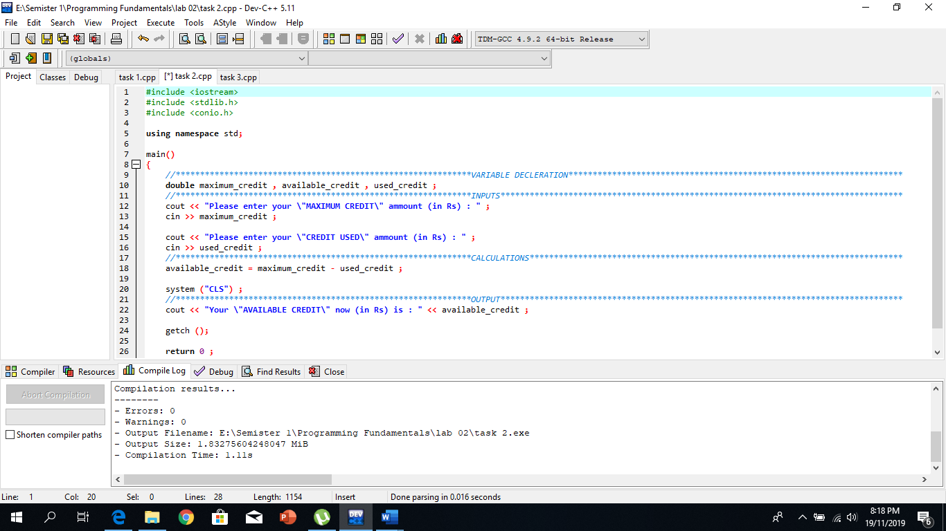

**OUTPUT:** 